Moss Park Elementary

Kindergarten Supply List 2023-2024

Please label the following items with your child’s name:

-1 standard **plastic** pencil box

-1 Primary Journal (***must have lines on the bottom and an empty space on top for pictures AND have 100 pages* )**

-1 pair Fiskar scissors

-1 clear view insert 3 ring binder, 1 inch

-1 pair of headphones that can plug into an iPad with a cover on it

-2 NO prong folders WITH holes (can be any design!)

Do NOT label:

-4 packs of **Crayola** Crayons

-30 glue sticks

-1 container Clorox wipes

1 bottle hand sanitizer

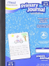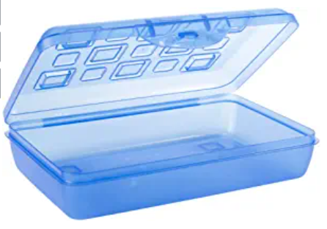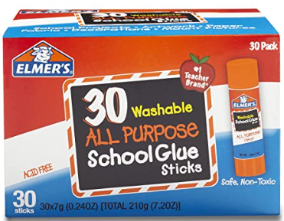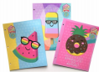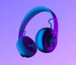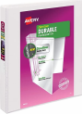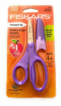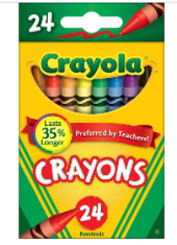

*Please make the following payment via SchoolPay.com to cover the purchase of community supplies for the classroom. This will allow each teacher to tailor the supplies to her needs for her classroom.*

*In addition, it also covers the cost of a Kindergarten t-shirt, to be distributed in September*

$30.00

Account to pay: Kindergarten Supplies

Please make payment by August 31, 2023

Thank you so much, 

The Moss Park Kindergarten Team